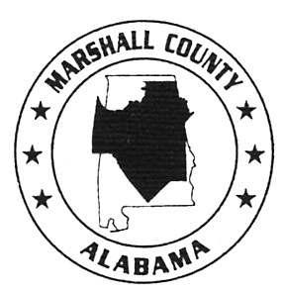

Incident Report

Marshall County, Alabama

Employee Name: | Date of incident: | Position:
Department: | Shift: | Supervisor:

Description of incident:

Performance impact:

Recommendations or commendations on performance:

Additional comments:

EMPLOYEE STATEMENT: Mark an “X” in the box that fits your employee statement.
I agree with the employer’s statement.
I do not agree with the employer’s statement. (Write your statement below. Attach additional sheets if needed.)

______________________________________________________________ __________________________________________
Employee Signature Date

______________________________________________________________ __________________________________________
Signature of Supervisor Date

MCAPF-17
Revised 10/14/2010

